Tasks on Aws -02
1.Launch one EC2 using Amazon Linux 2 image and add a script in user data to install Apache.
Steps used while creating While creating a Ec2 instance in the below we will be having the Option called User data That will help us to do the following step’s I will attach a image that what I have done User data
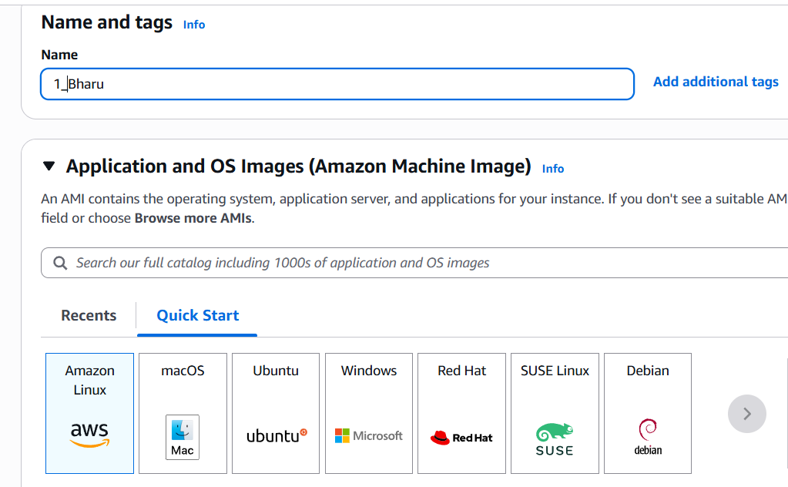
Over in user data section it’s mandatory to use a script so that we can install Httpd
I have attached the image
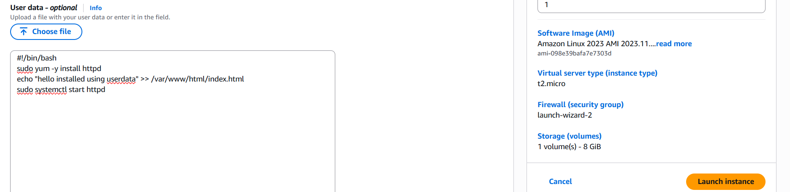
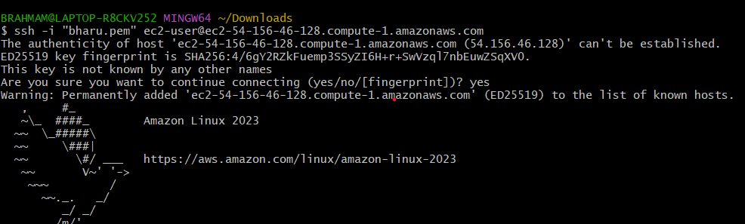
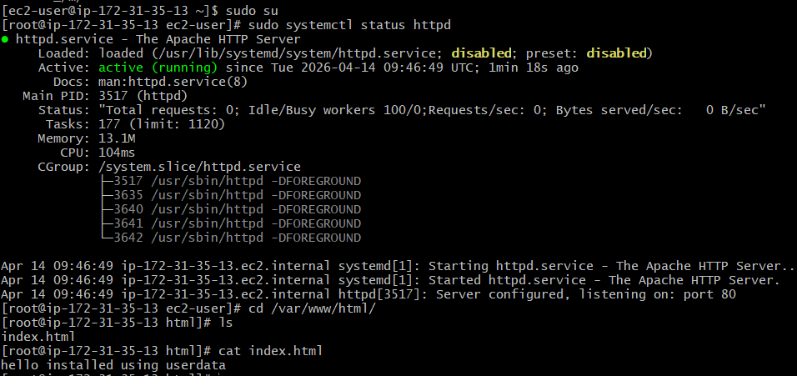
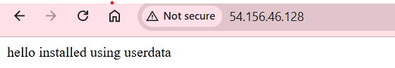
2.Launch one EC2 using Ubuntu image and add a script in user data to install Nginx.
Steps used while creating While creating a Ec2 instance this time it’s for ubuntu in the below we will be having the Option called User data That will help us to do the following step’s I will attach a image that what I have done User data
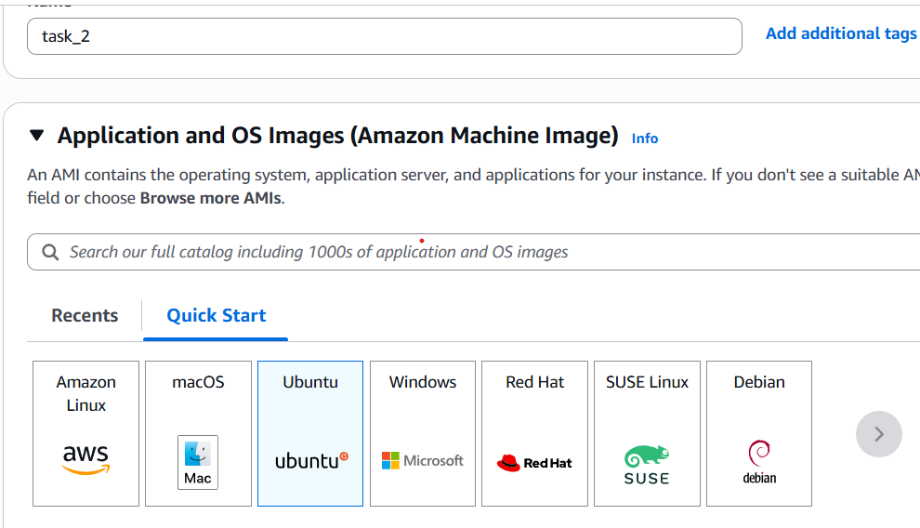
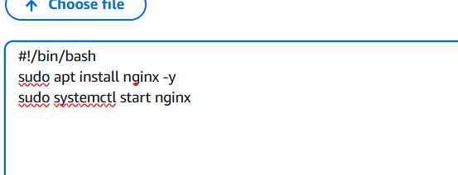
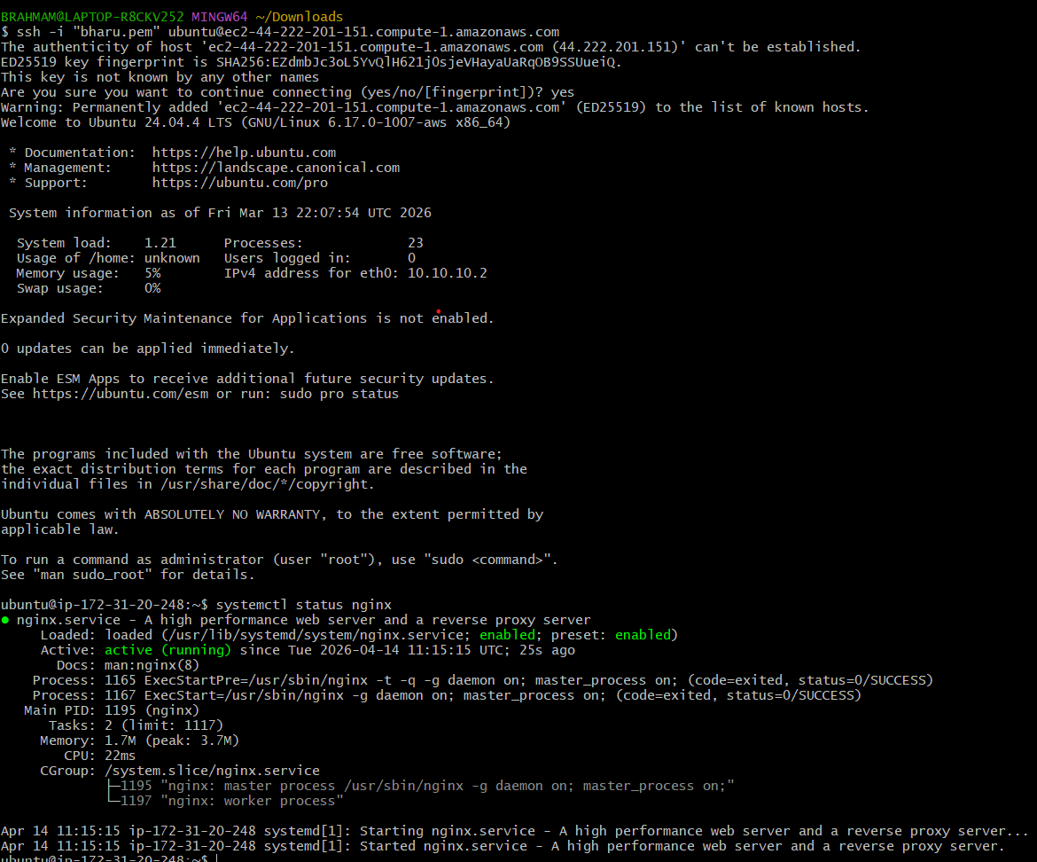
3.Launch one Windows server and install Tomcat on Windows.
Select the windows operating system and launch an windows instance
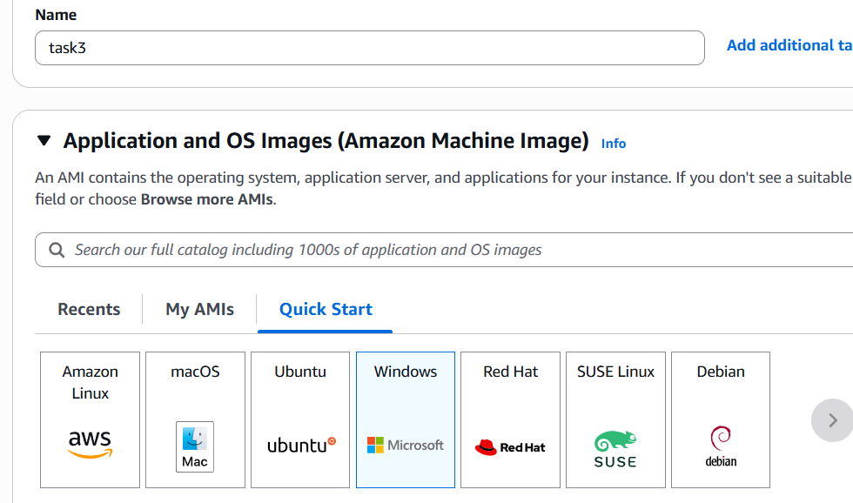
selected the Windows Operating System
logged into windows server
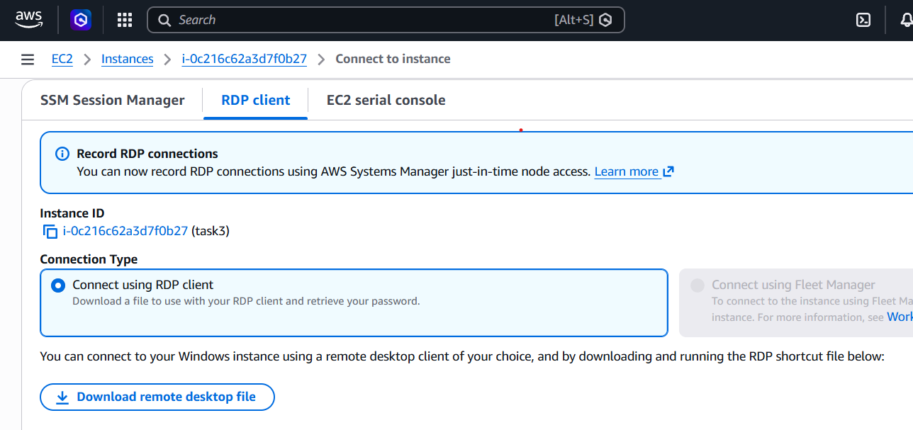
Password generated by given our pem file to that.
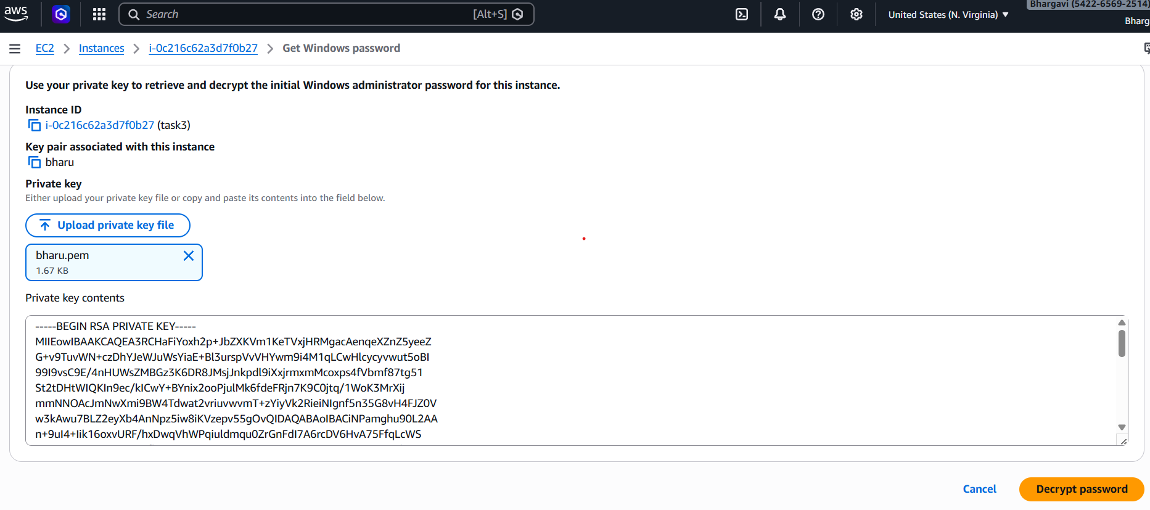
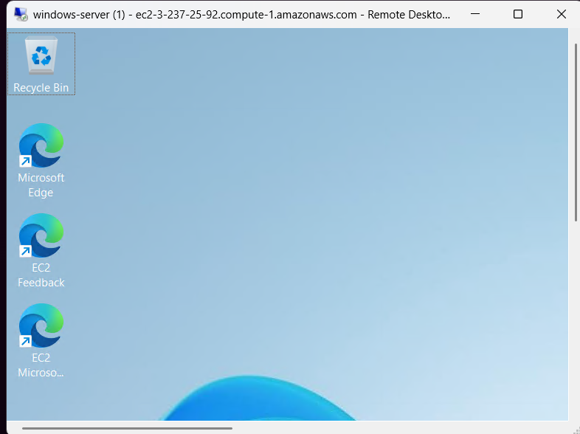
Now Install java and pass it in environment variable java oraclejava windows2nd link to downloadmentioned in below image how to pass env variable
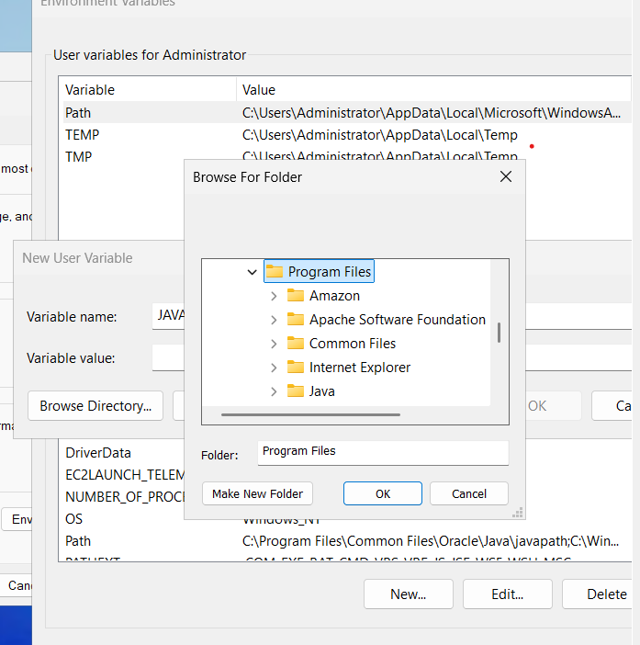

WE HAVE to add new file go to this pc and program filesjavajdk-26
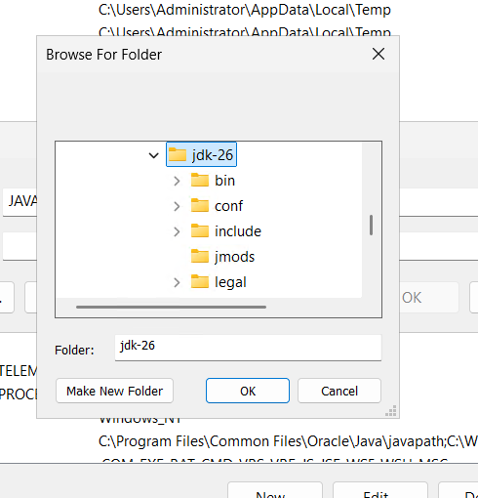
After completed env variables setting I want to check the java version was running or notcmdjava –version
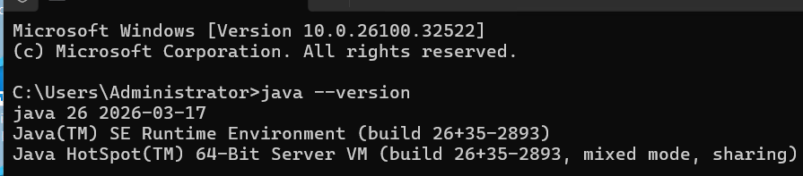
Microsoft go to search apache tomcat download tomcat 10download and inasatall check this successfully installed
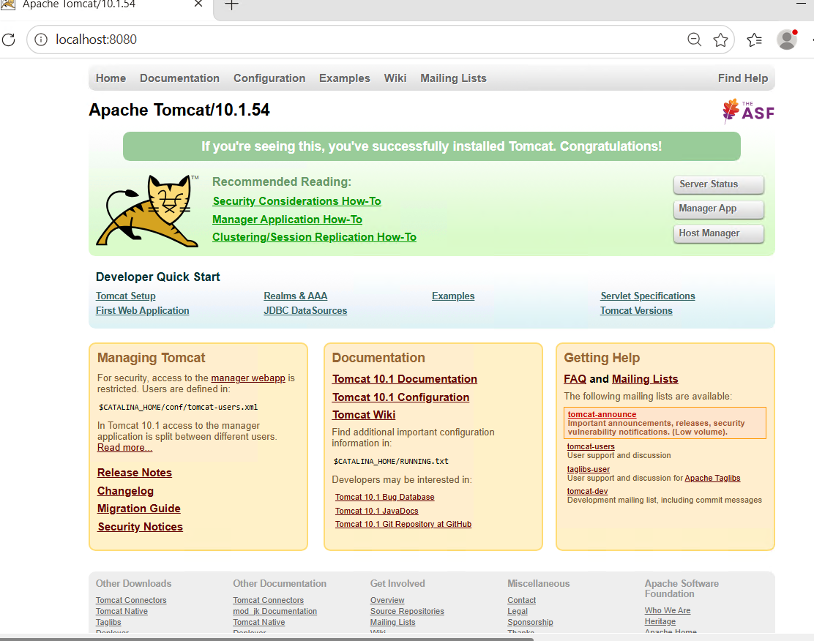
4.Take a snapshot of the instance created in Task 1.
To take a snapshot of an ec2 instance we will be having a option called snapshot click snapshot select the instance you want
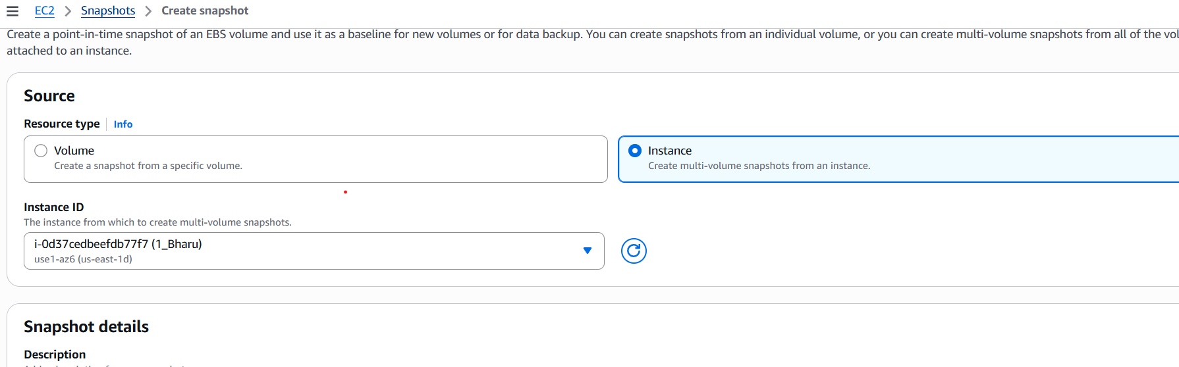
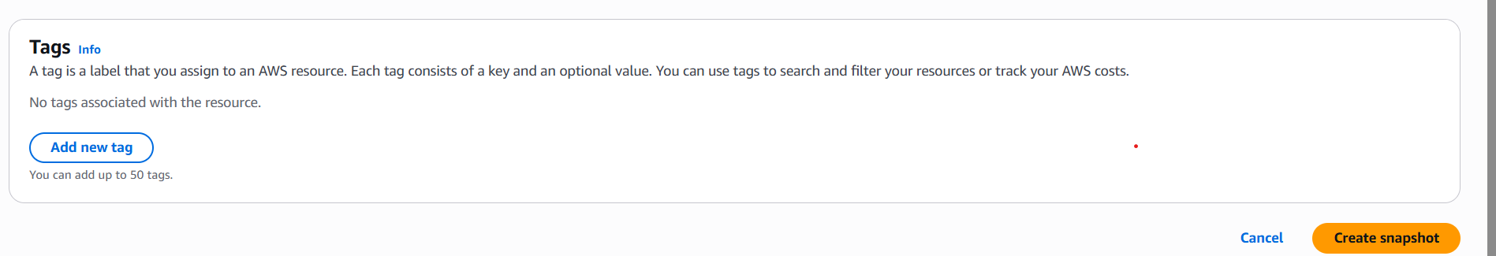
Now select the click create snapshot And create the snapshot
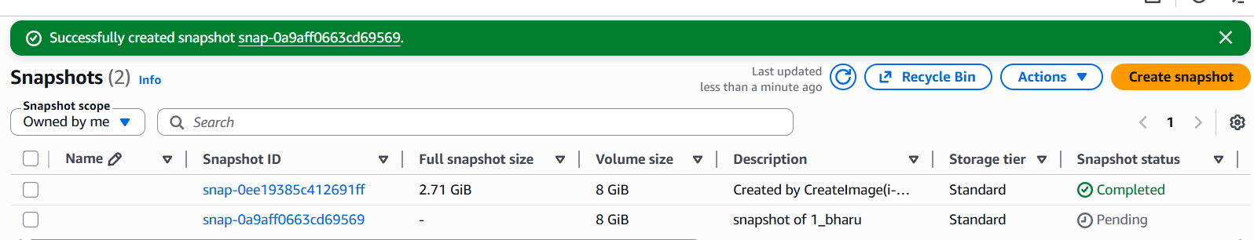
5.Assign passwordless authentication for the EC2 created in Task 2.
First create ssh-keygen in your local like mentioned below
Next login into instance go to cd .ssh over there you will have authorized key vi authorized_keys open this and paste the url it and paste the public key you copied from local and paste in then change the permission using and exit the login in using the command ssh ubuntu@public-ip
Now I have logged in without passwordless-authentication from local to central user
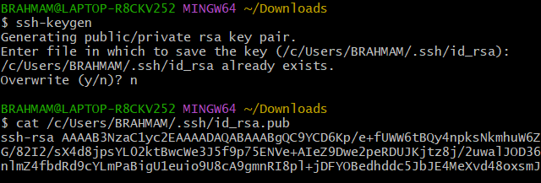
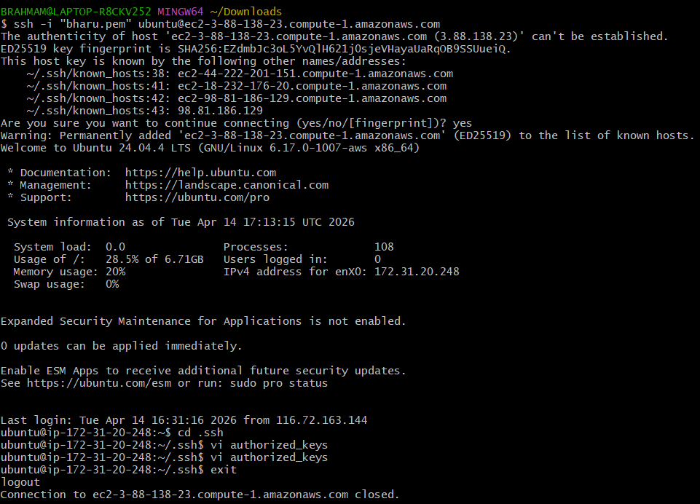
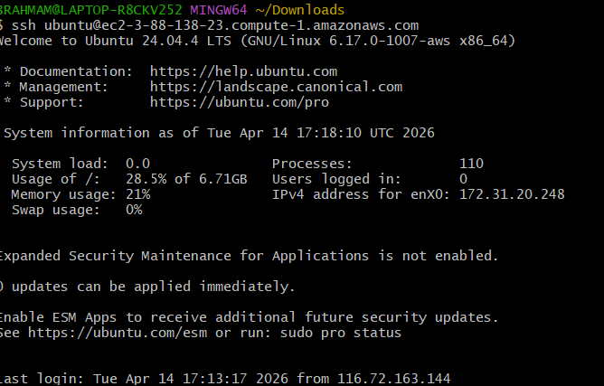

6.Launch any EC2 using the spot purchasing option.
Create spot instance using the below work
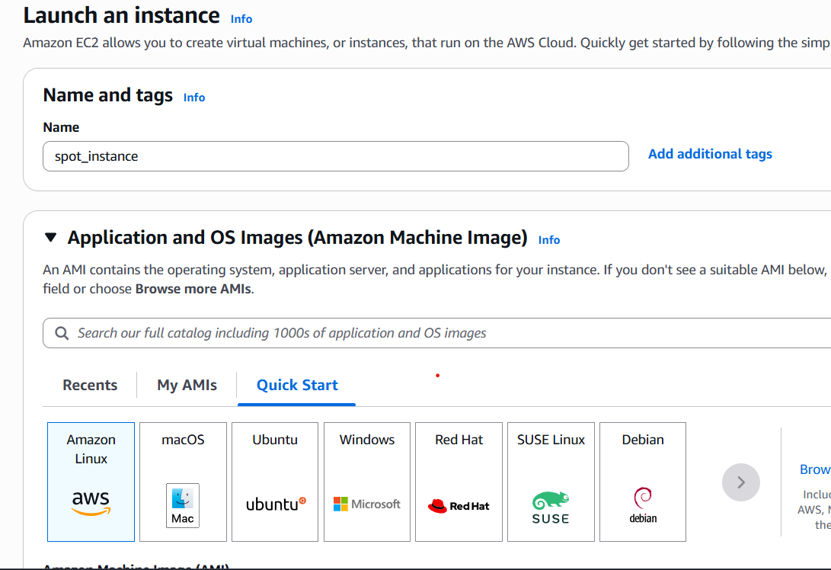
Now I have create the instance and check the spot request
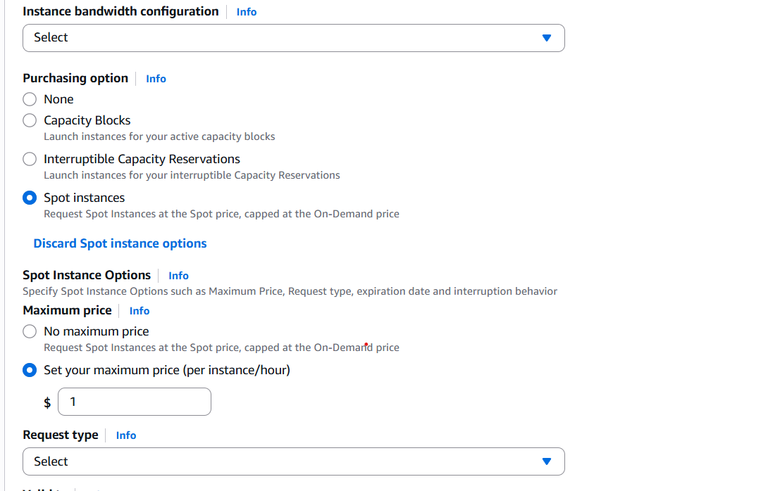
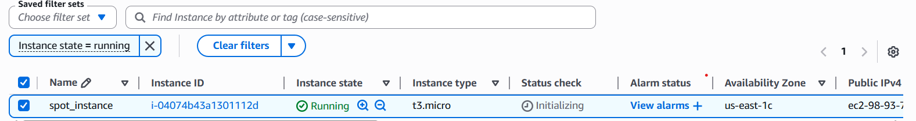

7.Enable termination policy on the EC2 created in Task 2.
Now to enable delete the termination process
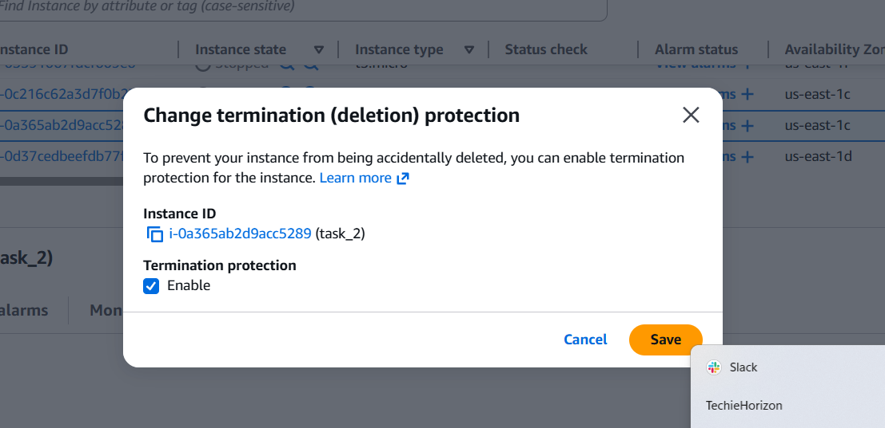
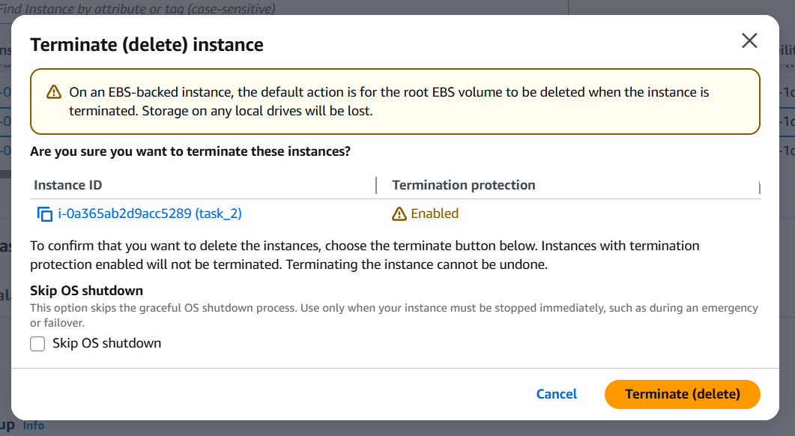
8.Launch one EC2 using AWS CLI.
First we have to go IAM
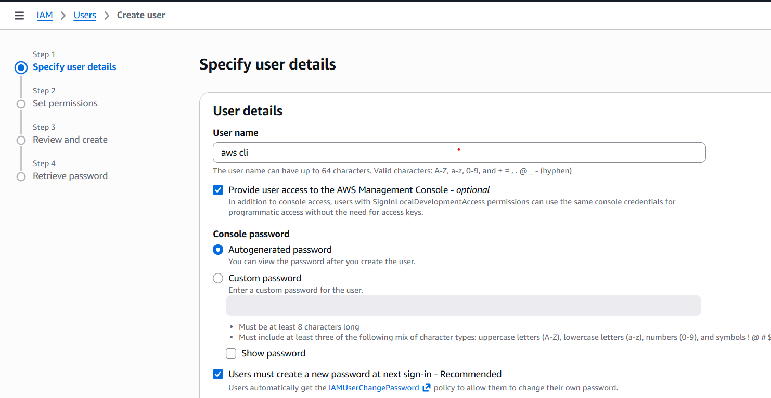
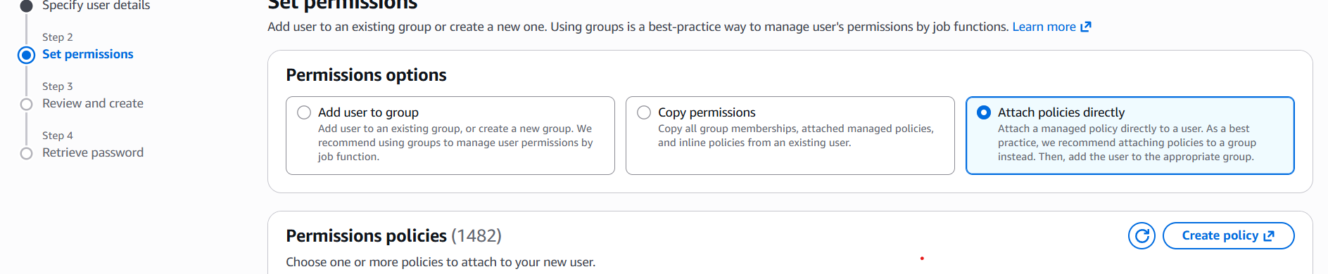
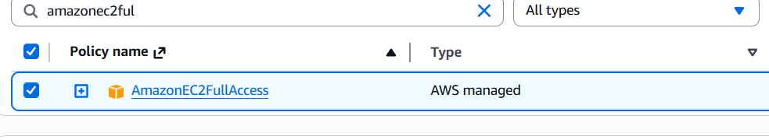
We see
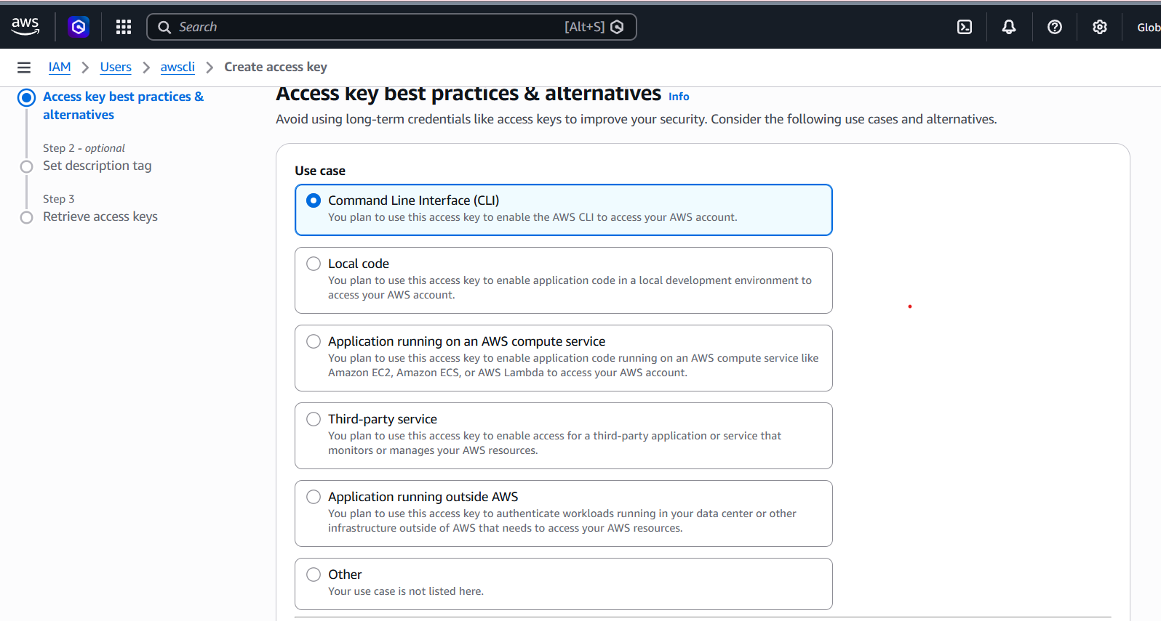
Now we want to install awscli using chrome windowsinstall
After completeing installing we go to git bash check aws –version seen in below
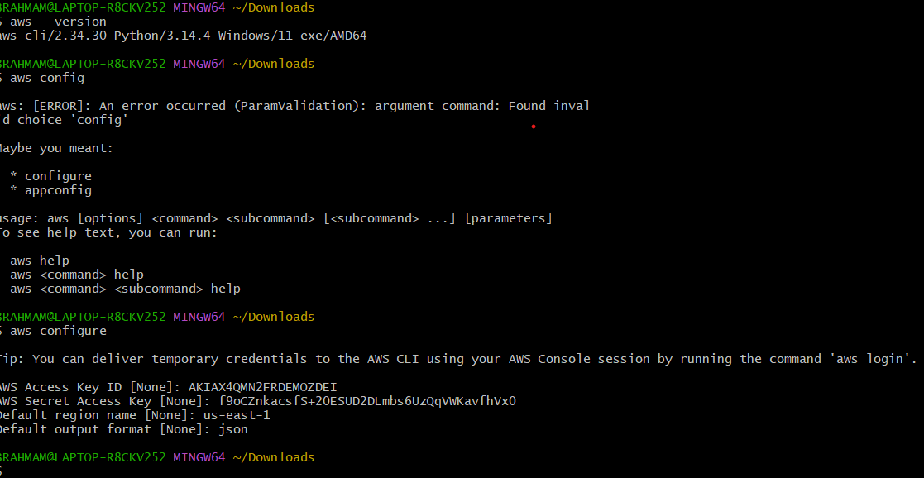
Nano aws.sh
aws ec2 run-instances \
--image-id ami-0c3389a4fa5bddaad \
--count 1 \
--instance-type t3.micro \
--key-name deekshi \
--security-group-ids sg-0a674e3272c6fbc72 \
--subnet-id subnet-094e38e94cb99accb \
--associate-public-ip-address \
--tag-specifications 'ResourceType=instance,Tags=[{Key=Name,Value=MyEC2}]'
